Temperature Prediction Module

We tried predicting temperature using Support Vector Machine (SVM) and checked the accuracy of the results by changing climatic parameters which affect the changes in temperature. Here we used daily weather dataset starting from 1st January, 2010. The Average error and the max difference between the predicted and original data are as follows –

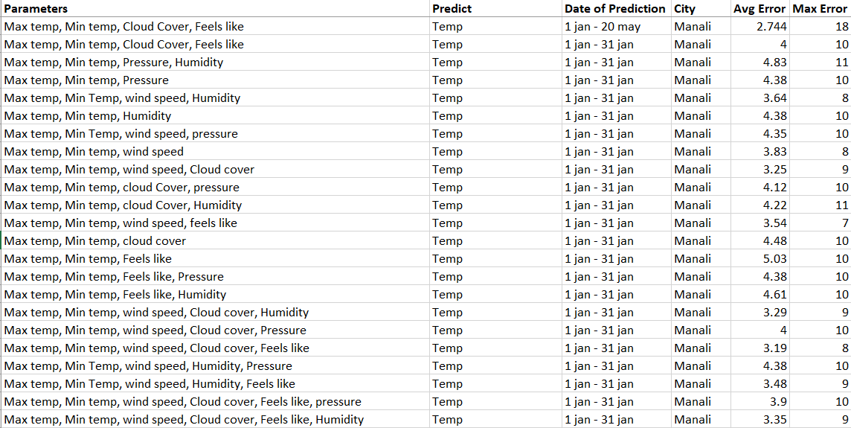

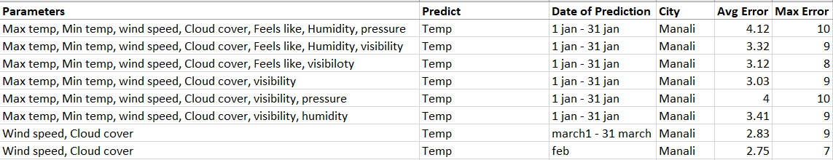

We tried all these parameters with Linear Regression (MLR) and we got better results in few of the parameters but still the average error was substantial. These above methods were not generalized as, they gave satisfactory results for temperatures in a particular range and gave extremely bad results otherwise.

We read in a paper that; the average error must be less than 2°C. So, we changed our training process altogether and came up with the idea to group months and years and then predict the temperature for a single month. This process gave astoundingly better results as the average error was brought down to almost 1-1.5°C. This process gave almost stable results for all temperature ranges.

We tested this method for 5 best test cases and the results for SVM with grouping are as follows –

*Note : The cases having the least average error are highlighted in the following tables.*

|  |  |  |  |  |  |
| --- | --- | --- | --- | --- | --- |
| **SVM with Grouping** | | | | | |
| **Case** | **Parameters** | **City** | **C** | **ME** | **Max Diff** |
| **1** | maxtempC', 'mintempC', 'cloudcover', 'visibility', 'windspeedKmph' | Ooty | 1165 | 0.8 | 2 |
| **2** | maxtempC', 'mintempC', 'cloudcover', 'visibility', 'windspeedKmph','FeelsLikeC' | Ooty | 307 | 0.6 | 1 |
| **3** | maxtempC', 'mintempC', 'cloudcover', 'windspeedKmph','FeelsLikeC' | Ooty | 2485 | 0.8 | 1 |
| **4** | maxtempC', 'mintempC', 'cloudcover', 'windspeedKmph' | Ooty | 1623 | 1 | 3 |
| **5** | maxtempC', 'mintempC', 'cloudcover', 'windspeedKmph','humidity' | Ooty | 374 | 1 | 2 |
|  |  |  |  |  |  |
| **1** | maxtempC', 'mintempC', 'cloudcover', 'visibility', 'windspeedKmph' | Manali | 300 | 1.8 | 4 |
| **2** | maxtempC', 'mintempC', 'cloudcover', 'visibility', 'windspeedKmph','FeelsLikeC' | Manali | 300 | 1.8 | 4 |
| **3** | maxtempC', 'mintempC', 'cloudcover', 'windspeedKmph','FeelsLikeC' | Manali | 300 | 2.2 | 5 |
| **4** | maxtempC', 'mintempC', 'cloudcover', 'windspeedKmph' | Manali | 300 | 2.2 | 5 |
| **5** | maxtempC', 'mintempC', 'cloudcover', 'windspeedKmph','humidity' | Manali | 300 | 1 | 2 |
|  |  |  |  |  |  |
| **1** | maxtempC', 'mintempC', 'cloudcover', 'visibility', 'windspeedKmph' | Mumbai | 300 | 1.2 | 2 |
| **2** | maxtempC', 'mintempC', 'cloudcover', 'visibility', 'windspeedKmph','FeelsLikeC' | Mumbai | 300 | 1.2 | 2 |
| **3** | maxtempC', 'mintempC', 'cloudcover', 'windspeedKmph','FeelsLikeC' | Mumbai | 300 | 1.6 | 3 |
| **4** | maxtempC', 'mintempC', 'cloudcover', 'windspeedKmph' | Mumbai | 300 | 1.4 | 3 |
| **5** | maxtempC', 'mintempC', 'cloudcover', 'windspeedKmph','humidity' | Mumbai | 964 | 1.2 | 2 |
|  |  |  |  |  |  |
| **1** | maxtempC', 'mintempC', 'cloudcover', 'visibility', 'windspeedKmph' | Rajkot | 1862 | 4 | 8 |
| **2** | maxtempC', 'mintempC', 'cloudcover', 'visibility', 'windspeedKmph','FeelsLikeC' | Rajkot | 2549 | 3.2 | 8 |
| **3** | maxtempC', 'mintempC', 'cloudcover', 'windspeedKmph','FeelsLikeC' | Rajkot | 2828 | 3.6 | 10 |
| **4** | maxtempC', 'mintempC', 'cloudcover', 'windspeedKmph' | Rajkot | 2553 | 4.6 | 9 |
| **5** | maxtempC', 'mintempC', 'cloudcover', 'windspeedKmph','humidity' | Rajkot | 853 | 3.4 | 10 |
|  |  |  |  |  |  |
| **1** | maxtempC', 'mintempC', 'cloudcover', 'visibility', 'windspeedKmph' | Sangli | 585 | 3.2 | 6 |
| **2** | maxtempC', 'mintempC', 'cloudcover', 'visibility', 'windspeedKmph','FeelsLikeC' | Sangli | 786 | 3.2 | 6 |
| **3** | maxtempC', 'mintempC', 'cloudcover', 'windspeedKmph','FeelsLikeC' | Sangli | 424 | 2.8 | 5 |
| **4** | maxtempC', 'mintempC', 'cloudcover', 'windspeedKmph' | Sangli | 478 | 2.8 | 5 |
| **5** | maxtempC', 'mintempC', 'cloudcover', 'windspeedKmph','humidity' | Sangli | 1958 | 4 | 6 |
|  |  |  |  |  |  |
| **1** | maxtempC', 'mintempC', 'cloudcover', 'visibility', 'windspeedKmph' | Bhopal | 1012 | 2 | 5 |
| **2** | maxtempC', 'mintempC', 'cloudcover', 'visibility', 'windspeedKmph','FeelsLikeC' | Bhopal | 2207 | 1.4 | 3 |
| **3** | maxtempC', 'mintempC', 'cloudcover', 'windspeedKmph','FeelsLikeC' | Bhopal | 2905 | 1.8 | 3 |
| **4** | maxtempC', 'mintempC', 'cloudcover', 'windspeedKmph' | Bhopal | 300 | 2.2 | 6 |
| **5** | maxtempC', 'mintempC', 'cloudcover', 'windspeedKmph','humidity' | Bhopal | 2839 | 1.4 | 2 |
|  |  |  |  |  |  |
| **1** | 'maxtempC', 'mintempC', 'cloudcover', 'visibility', 'windspeedKmph' | Dispur | 619 | 1.4 | 4 |
| **2** | maxtempC', 'mintempC', 'cloudcover', 'visibility', 'windspeedKmph','FeelsLikeC' | Dispur | 1616 | 1.2 | 3 |
| **3** | maxtempC', 'mintempC', 'cloudcover', 'windspeedKmph','FeelsLikeC' | Dispur | 1384 | 2.4 | 3 |
| **4** | maxtempC', 'mintempC', 'cloudcover', 'windspeedKmph' | Dispur | 300 | 3.4 | 5 |
| **5** | maxtempC', 'mintempC', 'cloudcover', 'windspeedKmph','humidity' | Dispur | 1644 | 2 | 3 |
|  |  |  |  |  |  |
| **1** | 'maxtempC', 'mintempC', 'cloudcover', 'visibility', 'windspeedKmph' | Jaipur | 300 | 3.2 | 7 |
| **2** | maxtempC', 'mintempC', 'cloudcover', 'visibility', 'windspeedKmph','FeelsLikeC' | Jaipur | 1616 | 1.2 | 3 |
| **3** | maxtempC', 'mintempC', 'cloudcover', 'windspeedKmph','FeelsLikeC' | Jaipur | 300 | 3.4 | 5 |
| **4** | maxtempC', 'mintempC', 'cloudcover', 'windspeedKmph' | Jaipur | 300 | 3.2 | 7 |
| **5** | maxtempC', 'mintempC', 'cloudcover', 'windspeedKmph','humidity' | Jaipur | 300 | 2.8 | 6 |

The same was tested with MLR –

|  |  |  |  |  |
| --- | --- | --- | --- | --- |
| **MLR** | | | | |
| **Case** | **Parameters** | **City** | **ME** | **Max Diff** |
| **1** | maxtempC', 'mintempC', 'cloudcover', 'visibility', 'windspeedKmph' | Ooty | 1 | 3 |
| **2** | maxtempC', 'mintempC', 'cloudcover', 'visibility', 'windspeedKmph','FeelsLikeC' | Ooty | 1 | 3 |
| **3** | maxtempC', 'mintempC', 'cloudcover', 'windspeedKmph','FeelsLikeC' | Ooty | 2.6 | 4 |
| **4** | maxtempC', 'mintempC', 'cloudcover', 'windspeedKmph' | Ooty | 2.6 | 4 |
| **5** | maxtempC', 'mintempC', 'cloudcover', 'windspeedKmph','humidity' | Ooty | 1.4 | 2 |
|  |  |  |  |  |
| **1** | maxtempC', 'mintempC', 'cloudcover', 'visibility', 'windspeedKmph' | Manali | 2.6 | 5 |
| **2** | maxtempC', 'mintempC', 'cloudcover', 'visibility', 'windspeedKmph','FeelsLikeC' | Manali | 2.4 | 4 |
| **3** | maxtempC', 'mintempC', 'cloudcover', 'windspeedKmph','FeelsLikeC' | Manali | 2.4 | 4 |
| **4** | maxtempC', 'mintempC', 'cloudcover', 'windspeedKmph' | Manali | 2.8 | 5 |
| **5** | maxtempC', 'mintempC', 'cloudcover', 'windspeedKmph','humidity' | Manali | 1.4 | 4 |
|  |  |  |  |  |
| **1** | maxtempC', 'mintempC', 'cloudcover', 'visibility', 'windspeedKmph' | Mumbai | 1.6 | 2 |
| **2** | maxtempC', 'mintempC', 'cloudcover', 'visibility', 'windspeedKmph','FeelsLikeC' | Mumbai | 1.8 | 2 |
| **3** | maxtempC', 'mintempC', 'cloudcover', 'windspeedKmph','FeelsLikeC' | Mumbai | 1.6 | 2 |
| **4** | maxtempC', 'mintempC', 'cloudcover', 'windspeedKmph' | Mumbai | 1.8 | 3 |
| **5** | maxtempC', 'mintempC', 'cloudcover', 'windspeedKmph','humidity' | Mumbai | 1.8 | 2 |
|  |  |  |  |  |
| **1** | maxtempC', 'mintempC', 'cloudcover', 'visibility', 'windspeedKmph' | Rajkot | 3.4 | 7 |
| **2** | maxtempC', 'mintempC', 'cloudcover', 'visibility', 'windspeedKmph','FeelsLikeC' | Rajkot | 3.2 | 8 |
| **3** | maxtempC', 'mintempC', 'cloudcover', 'windspeedKmph','FeelsLikeC' | Rajkot | 3.4 | 7 |
| **4** | maxtempC', 'mintempC', 'cloudcover', 'windspeedKmph' | Rajkot | 3.8 | 7 |
| **5** | maxtempC', 'mintempC', 'cloudcover', 'windspeedKmph','humidity' | Rajkot | 3.4 | 7 |
|  |  |  |  |  |
| **1** | maxtempC', 'mintempC', 'cloudcover', 'visibility', 'windspeedKmph' | Sangli | 4 | 6 |
| **2** | maxtempC', 'mintempC', 'cloudcover', 'visibility', 'windspeedKmph','FeelsLikeC' | Sangli | 4 | 7 |
| **3** | maxtempC', 'mintempC', 'cloudcover', 'windspeedKmph','FeelsLikeC' | Sangli | 4.4 | 8 |
| **4** | maxtempC', 'mintempC', 'cloudcover', 'windspeedKmph' | Sangli | 4.6 | 7 |
| **5** | maxtempC', 'mintempC', 'cloudcover', 'windspeedKmph','humidity' | Sangli | 3.8 | 6 |
|  |  |  |  |  |
| **1** | maxtempC', 'mintempC', 'cloudcover', 'visibility', 'windspeedKmph' | Bhopal | 2.8 | 5 |
| **2** | maxtempC', 'mintempC', 'cloudcover', 'visibility', 'windspeedKmph','FeelsLikeC' | Bhopal | 3.4 | 6 |
| **3** | maxtempC', 'mintempC', 'cloudcover', 'windspeedKmph','FeelsLikeC' | Bhopal | 3.2 | 6 |
| **4** | maxtempC', 'mintempC', 'cloudcover', 'windspeedKmph' | Bhopal | 3 | 5 |
| **5** | maxtempC', 'mintempC', 'cloudcover', 'windspeedKmph','humidity' | Bhopal | 3.2 | 5 |
|  |  |  |  |  |
| **1** | 'maxtempC', 'mintempC', 'cloudcover', 'visibility', 'windspeedKmph' | Dispur | 3.6 | 6 |
| **2** | maxtempC', 'mintempC', 'cloudcover', 'visibility', 'windspeedKmph','FeelsLikeC' | Dispur | 3 | 5 |
| **3** | maxtempC', 'mintempC', 'cloudcover', 'windspeedKmph','FeelsLikeC' | Dispur | 3 | 5 |
| **4** | maxtempC', 'mintempC', 'cloudcover', 'windspeedKmph' | Dispur | 3.2 | 5 |
| **5** | maxtempC', 'mintempC', 'cloudcover', 'windspeedKmph','humidity' | Dispur | 3.2 | 5 |
|  |  |  |  |  |
| **1** | 'maxtempC', 'mintempC', 'cloudcover', 'visibility', 'windspeedKmph' | Jaipur | 3.6 | 7 |
| **2** | maxtempC', 'mintempC', 'cloudcover', 'visibility', 'windspeedKmph','FeelsLikeC' | Jaipur | 3.2 | 6 |
| **3** | maxtempC', 'mintempC', 'cloudcover', 'windspeedKmph','FeelsLikeC' | Jaipur | 3.2 | 6 |
| **4** | maxtempC', 'mintempC', 'cloudcover', 'windspeedKmph' | Jaipur | 3.6 | 7 |
| **5** | maxtempC', 'mintempC', 'cloudcover', 'windspeedKmph','humidity' | Jaipur | 2.8 | 6 |

The Average Errors and the Maximum Differences in the 3 approaches are visualized as follows –

|  |  |  |  |  |  |  |
| --- | --- | --- | --- | --- | --- | --- |
| **Case 1** | maxtempC | mintempC | cloudcover | visibility | windspeedKmph |  |
| **Case 2** | maxtempC | mintempC | cloudcover | visibility | windspeedKmph | FeelsLikeC |
| **Case 3** | maxtempC | mintempC | cloudcover | windspeedKmph | FeelsLikeC |  |
| **Case 4** | maxtempC | mintempC | cloudcover | windspeedKmph |  |  |
| **Case 5** | maxtempC | mintempC | cloudcover | windspeedKmph | humidity |  |